A

Mini Project Report

On

**Machine Learning Deployment on AWS SageMaker**

*Submitted to CMR ENGINEERING COLLEGE*

*In Partial Fulfillment of the requirements for the Award of Degree of*

**BACHELOR OF TECHNOLOGY**

**IN**

**COMPUTER SCIENCE AND ENGINEERING**

Submitted

By

**B. Ravi Kumar (228R1A05L1)**

**K. Kavitha (228R1A05N0)**

**K. Sai Saanvi (228R1A05N4)**

**N. Eswari (228R1A05P9)**

**K. Akhil Yadav (238R5A0528)**

Under the Esteemed guidance of

**Ms. Sai Manasa**

Assistant Professor, Department of CSE



**Department of Computer Science & Engineering**

**CMR ENGINEERING COLLEGE**

**UGC AUTONOMOUS**

(Approved by AICTE, NEW DELHI, Affiliated to JNTU, Hyderabad)

Kandlakoya, Medchal Road, R.R. Dist. Hyderabad-501 401)

**2024-2025**

**CMR ENGINEERING COLLEGE**

**UGC AUTONOMOUS**

*(Accredited by NBA,Approved by AICTE NEW DELHI, Affiliated to JNTU, Hyderabad)*

*Kandlakoya, Medchal Road, Hyderabad-501 401*

**Department of Computer Science & Engineering**



**CERTIFICATE**

This is to certify that the project entitled **“Machine Learning Deployment on AWS SageMaker”** is a bonafide work carried out by

**B. Ravi Kumar (228R1A05L1)**

**K. Kavitha (228R1A05N0)**

**K. Sai Saanvi (228R1A05N4)**

**N. Eswari (228R1A05P9)**

**K. Akhil Yadav (238R5A0528)**

in partial fulfillment of the requirement for the award of the degree of **BACHELOR OF TECHNOLOGY** in **COMPUTER SCIENCE AND ENGINEERING** from CMR Engineering College, affiliated to JNTU, Hyderabad, under our guidance and supervision.

The results presented in this Mini project have been verified and are found to be satisfactory. The results embodied in this Mini project have not been submitted to any other university for the award of any other degree or diploma.

|  |  |  |
| --- | --- | --- |
| **Internal Guide** | **Mini Project Coordinator** | **Head of the Department** |
| **Ms. Sai Manasa** | **Mr. S Kiran Kumar** | **Dr. Sheo Kumar** |
| Assistant Professor | Assistant Professor | Professor & H.O.D |
| Department of CSE,  CMREC, Hyderabad | Department of CSE,  CMREC, Hyderabad | Department of CSE,  CMREC, Hyderabad |

**External Examiner**

**DECLARATION**

This is to certify that the work reported in the present Mini project entitled **‘‘Machine Learning Deployment on AWS SageMaker”** is a record of bonafide work done by us in the Department of Computer Science and Engineering, CMR Engineering College, JNTU Hyderabad. The reports are based on the project work done entirely by us and not copied from any other source. We submit our project for further development by any interested students who share similar interests to improve the project in the future.

The results embodied in this Mini project report have not been submitted to any other University or Institute for the award of any degree or diploma to the best of our knowledge and belief.

**B. Ravi Kumar (228R1A05L1)**

**K. Kavitha (228R1A05N0)**

**K. Sai Saanvi (228R1A05N4)**

**N. Eswari (228R1A05P9)**

**K. Akhil Yadav (238R5A0528)**

**ACKNOWLEDGMENT**

We are extremely grateful to **Dr. A. Srinivasula Reddy**, Principal and **Dr. Sheo Kumar**, HOD, **Department of CSE, CMR Engineering College** for their constant support**.**

We are extremely thankful to **Ms. Sai Manasa**, Assistant Professor, Internal Guide, Department of CSE, for her constant guidance, encouragement and moral support throughout the project.

We will be failing in duty if we do not acknowledge with grateful thanks to the authors of the references and other literatures referred in this Project.

We thank **Mr. S Kiran Kumar, Assistant Professor, CSE Department**, Mini Project Coordinator for his constant support in carrying out the project activities and reviews.

We express my thanks to all staff members and friends for all the help and co-ordination extended in bringing out this project successfully in time.

Finally, we are very much thankful to our parents who guided me for every step.

**B. Ravi Kumar (228R1A05L1)**

**K. Kavitha (228R1A05N0)**

**K. Sai Saanvi (228R1A05N4)**

**N. Eswari (228R1A05P9)**

**K. Akhil Yadav (238R5A0528)**

**CONTENTS**

**TOPIC PAGENO**

**ABSTRACT i**

**LIST OF FIGURES ii**

**LIST OF TABLES ii**

**1. INTRODUCTION**

1.1 Introduction and Objectives 01

1.2 Purpose of the Project 04

1.3 Existing System and Disadvantages 06

1.4 Proposed System and Advantages 07

**2. LITERATURE SURVEY** 08

**3. SOFTWARE REQUIREMENT ANALYSIS**

3.1 Problem Specification 09

3.2 Modules 09

3.3 Functional Requirements 10

3.4 Non-Functional Requirements 11

3.5 Feasibility Study 11

**4. SOFTWARE AND HARDWARE REQUIREMENTS**

4.1 Hardware Configuration 18

4.2 Software Configuration 18

**5. SOFTWARE DESIGN**

5.1 Data Flow Diagrams 19

5.2 UML Diagrams 20

5.3 System Architecture 23

**6. CODING AND IMPLEMENTATION**

6.1 Methodology 24

6.1 Sample Code 26

**7. TESTING**

7.1 Introduction of Testing 39

7.2 Unit Testing 40

7.3 Integration Testing 40

**8. OUTPUT SCREENS** 41

**9. CONCLUSION** 47

**10. FUTURE ENHANCEMENTS** 48

**11. REFERENCES**

11.1 **Text Books** 49

11.2 **Websites** 49

**ABSTRACT**

**ABSTRACT**

Traffic congestion is one of the most critical problems in urban areas, causing increased travel time, fuel consumption, and air pollution. Traditional traffic light systems operate on fixed timers that do not adapt to real-time traffic flow, resulting in inefficient traffic management. To address this issue, our project presents a Smart Traffic System that dynamically adjusts signal durations based on real-time vehicle density using a machine learning model deployed in Amazon SageMaker.

The system leverages a pre-trained YOLOv8 (You Only Look Once) model to detect and classify vehicles in images. Vehicle categories such as cars, trucks, buses, and motorcycles are identified from images captured at traffic intersections. A Python-based script processes these images to count the number of vehicles present. Based on the vehicle count, an algorithm calculates the optimal green signal duration. For example, if the vehicle count is low (less than or equal to five), a minimal green light duration is assigned. As the traffic density increases, the system proportionally increases the green light time to ensure smooth traffic flow and reduce congestion.

The model is integrated into a web-based interface using the Flask framework. Users can upload traffic images through the web app, and the backend processes the image, performs object detection, and displays both the number of vehicles and the recommended green signal time. The image is also annotated with detection boxes and labels, providing visual feedback.

The core object detection model is deployed on Amazon SageMaker, showcasing the power of cloud-based ML services for scalable, real-time applications. By using SageMaker, the system benefits from high availability, scalability, and managed infrastructure, making it suitable for deployment in large-scale smart city environments.

This project not only demonstrates the practical deployment of a machine learning model but also addresses a pressing urban infrastructure problem using intelligent automation. The Smart Traffic System can serve as a building block for future smart city initiatives, offering a cost-effective, efficient, and adaptive traffic control mechanism that enhances mobility and reduces environmental impact.

**i**

**LIST OF FIGURES**

|  |  |  |  |  |
| --- | --- | --- | --- | --- |
| **S. NO.** | **FIG. NO.** | **DESCRIPTION** | | **PAGE NO.** |
| 1 | 5.1.1 | Class Diagram | | 19 |
| 2 | 5.2.1 | Use Case Diagram | | 20 |
| 3 | 5.2.2 | Sequence Diagram | | 21 |
| 4 | 5.2.3 | Activity Diagram | | 22 |
| 5 | 5.3.1 | System Architecture | | 23 |
| 6 | 8.a | Main Page | | 41 |
| 7 | 8.b | Selection of images | | 41 |
| 8 | 8.c | Main Page after selection | | 42 |
| 9  10  11  12  13  14  15  16 | 8.d  8.e  8.f  8.g  8.h  8.i  8.j  8.k | Result Page  SageMaker Domain Creation  Project Folder  SageMaker Studio  Deployment of Model  Testing  Creation of S3 Bucket  Uploading of Model | 42  43  43  44  44  45  45  46 | |

**LIST OF TABLES**

|  |  |  |
| --- | --- | --- |
| **S. NO.** | **DESCRIPTION** | **PAGE NO.** |
| 1 | Literature Survey | 06 |
| 2 | System Testing | 39 |
| 3 | Unit Testing | 40 |
| 4 | Integration Testing | 40 |

ii

CHAPTER - 1

**INTRODUCTION**

**1. INTRODUCTION**

**1.1 INTRODUCTION AND OBJECTIVES**

Traffic congestion has become a major challenge in urban areas worldwide. As cities grow and vehicle ownership increases, traditional traffic control mechanisms struggle to keep pace with the dynamic nature of urban mobility. Congested intersections, long queues, fuel wastage, increased travel times, and pollution are some of the adverse outcomes of poorly managed traffic systems. Despite significant advancements in infrastructure, most cities still rely on conventional traffic signal systems that operate on pre-defined timers. These systems fail to adapt to real-time traffic conditions, leading to inefficiencies and frustrated commuters.

In the current era of smart cities and automation, there is a pressing need to transition from static traffic management systems to intelligent and adaptive solutions. Emerging technologies like artificial intelligence (AI), machine learning (ML), computer vision, and the Internet of Things (IoT) provide powerful tools to address these challenges. One such solution is the integration of real-time traffic detection and ML-driven decision-making to optimize traffic signal timing.

This project aims to develop a **Smart Traffic System** that uses a computer vision model for vehicle detection and a cloud-based machine learning service (Amazon SageMaker) for deployment and scalability. The system's core functionality revolves around using YOLOv8 (You Only Look Once, version 8), a powerful object detection model that identifies and counts vehicles from traffic images. Based on the number and type of detected vehicles, the system calculates and recommends an optimized green light duration for traffic signals. This adaptive control mechanism ensures that green lights are extended during high traffic and shortened when traffic is minimal, enhancing the flow of vehicles through intersections.

The entire workflow integrates a Flask-based web interface for user interaction, where users can upload traffic images and view the processed results. Behind the scenes, the image is analyzed using the YOLOv8 model, and the results are displayed along with the calculated signal duration. The object detection model, along with the logic for green time computation, is deployed on **Amazon SageMaker**, demonstrating real-world ML deployment practices in a scalable and cost-effective environment.

This project not only solves a real-world problem but also highlights the application of deep learning in infrastructure, providing valuable experience in end-to-end ML model integration, deployment, and web-based interaction. With the increasing focus on smart cities, such intelligent traffic systems represent a significant step toward creating more efficient and sustainable urban environments.

As the number of vehicles on the road increases day by day, the limitations of traditional traffic systems become increasingly evident. These systems generally operate on fixed intervals and do not consider real-time traffic fluctuations, leading to inefficient traffic flow and longer wait times for commuters. Even the best-designed infrastructure can fall short if the traffic control mechanisms are outdated or incapable of adapting to changing scenarios. These shortcomings become particularly apparent during peak hours, public events, or emergencies, where traffic patterns deviate significantly from the norm.

Moreover, emergency vehicles such as ambulances, fire trucks, or police vans often get stuck in long queues due to unresponsive traffic signals, risking lives and reducing the overall responsiveness of emergency services. Therefore, there is a growing demand for adaptive and automated traffic signal systems that can perceive traffic in real time and respond accordingly. The use of AI and machine learning in this context opens up immense possibilities for automation, optimization, and intelligent decision-making.

Object detection, one of the most promising areas of computer vision, allows machines to "see" and "understand" what's happening in a visual scene. In traffic management, this means being able to identify how many vehicles are at a particular intersection, what types of vehicles they are, and where they are positioned. This real-time data can then be processed and translated into actionable insights — such as how long to keep a particular traffic light green. YOLOv8 (You Only Look Once, version 8), the latest version of the popular YOLO object detection family, is particularly well-suited for this purpose due to its speed, accuracy, and efficiency in detecting multiple object classes in a single pass.

In this project, the YOLOv8 model has been trained and fine-tuned to detect key vehicle types such as cars, buses, motorcycles, and trucks. Once detected, the number of vehicles is used as the primary input to calculate the duration for which a traffic light should remain green. A custom algorithm, designed to account for both low and high traffic volumes, determines the most appropriate green light time based on the number and types of vehicles detected in each image.

What makes this project more impactful is the use of **Amazon SageMaker**, a cloud-based machine learning platform that simplifies the process of building, training, and deploying machine learning models. SageMaker provides the necessary infrastructure to run inference in the cloud, enabling the system to scale to handle larger datasets, real-time streaming, or integration into smart city ecosystems. By deploying the YOLOv8 model on SageMaker, the system not only becomes more robust and production-ready but also sets a foundation for integrating AI into public infrastructure services.

The Flask web application created for this project serves as a user-friendly interface through which users — or future government systems — can upload traffic images and instantly get results, including annotated images and green light durations. The use of Flask ensures easy integration of the model with front-end applications while offering RESTful endpoints for potential API expansion. The overall system architecture emphasizes modularity, making it easier to upgrade individual components such as the detection algorithm, user interface, or backend infrastructure.

Furthermore, this project encourages the practical implementation of AI ethics and responsible computing. For example, data privacy is maintained as no personal data is used or shared. Also, the system can be tuned to ensure fairness — avoiding any bias towards specific lanes or directions. This project has the potential to be extended beyond its current capabilities. Future versions could include live video feed support, integration with traffic light hardware via IoT modules, cloud dashboards for monitoring, and even the inclusion of vehicle tracking and prediction models using deep learning frameworks like LSTM or Transformer architectures.

In the broader scope of urban innovation, such AI-powered systems pave the way for more connected, intelligent, and sustainable cities. They reduce reliance on human-operated systems, minimize error, enhance safety, and promote better use of fuel and time. As governments and municipalities strive to improve quality of life through smart city initiatives, projects like this serve as crucial building blocks in developing next-generation infrastructure solutions.

The primary objective of this project is to develop an intelligent traffic control system that dynamically adjusts traffic signal durations based on real-time vehicle detection using deep learning. By leveraging the YOLOv8 object detection model, the system aims to accurately identify and count different types of vehicles such as cars, buses, motorcycles, and trucks in traffic images. A key goal is to deploy the machine learning model using Amazon SageMaker, demonstrating the capability of cloud-based platforms to handle model inference efficiently and at scale. The system also aims to provide a simple and intuitive web interface using Flask, allowing users to upload traffic images and receive processed results with vehicle counts and calculated green time. Another important objective is to create a scalable and modular architecture that can be expanded to real-time video streams or integrated with IoT-based traffic lights. The project also emphasizes practical implementation in smart city contexts, encouraging the use of AI for public infrastructure improvement. Ultimately, this system aspires to improve road safety, reduce emergency response delays, and contribute to the foundation of intelligent transportation solutions for modern urban environments.

**1.2 PURPOSE OF THE PROJECT**

In modern urban environments, traffic congestion is one of the most persistent and critical issues affecting daily life. The ever-increasing number of vehicles on roads, inadequate infrastructure, and static traffic signal systems contribute to long wait times, fuel wastage, and increased pollution. Traditional traffic light control systems are typically pre-programmed and operate on fixed schedules, regardless of the real-time traffic conditions. As a result, these systems often fail to respond dynamically to varying traffic loads, especially during peak hours, emergencies, or unexpected disruptions. This inefficiency calls for a more adaptive, intelligent system that can analyze real-time data and make informed decisions to manage traffic effectively.

The primary purpose of this project is to design and develop a Smart Traffic Signal Control System powered by Artificial Intelligence (AI) that addresses these inefficiencies. By leveraging the capabilities of the YOLOv8 (You Only Look Once version 8) object detection model and Amazon SageMaker, the proposed solution aims to detect and count vehicles in traffic images and dynamically adjust green light durations based on vehicle density. This AI-driven approach replaces the traditional fixed-time model with a responsive system that optimizes signal timings in real time, enhancing traffic flow and reducing congestion.

One of the key motivations behind this project is to integrate machine learning and cloud computing technologies into real-world infrastructure to demonstrate how advanced computational models can be utilized to solve everyday problems. YOLOv8, known for its speed and accuracy, is capable of detecting multiple objects in a single pass. This makes it an ideal choice for real-time vehicle detection in traffic scenarios. The system identifies relevant vehicle classes such as cars, buses, motorcycles, and trucks from images, counts them, and then determines an appropriate duration for the green traffic signal based on predefined logic. This ensures that roads with heavier traffic receive longer green times, thereby reducing waiting periods and congestion in busier lanes.

Amazon SageMaker plays a crucial role in the deployment of the YOLOv8 model. As a fully managed service for building, training, and deploying machine learning models, SageMaker provides scalability and flexibility to run inference efficiently on cloud infrastructure. The use of SageMaker not only demonstrates a modern method of deploying ML models but also allows for easy integration into larger systems and future scalability into edge devices or smart sensors deployed at traffic intersections.

Another important purpose of the project is to develop a web-based interface using Flask that allows users to interact with the system effortlessly. Through this interface, users can upload traffic images, which are then processed by the YOLOv8 model hosted on SageMaker. The results, including the number of vehicles detected and the calculated green signal time, are displayed in a user-friendly format. This provides transparency and insight into the model's decision-making process and makes it easy for traffic authorities or developers to monitor and evaluate system performance.

Beyond technical implementation, this project also serves an academic purpose by bridging theoretical knowledge with practical application. It demonstrates how computer vision and machine learning can be integrated with web development and cloud computing to build a full-stack AI application. This project acts as a learning platform to understand end-to-end ML pipelines—from model training and deployment to real-world inference and visualization.

From a societal perspective, the project aspires to lay the groundwork for smart cities, where data-driven decisions lead to better management of urban challenges. The adaptive traffic system not only improves traffic flow but also enhances road safety by minimizing the chances of signal violations and accidents caused by inefficient signal timings. Furthermore, by reducing vehicle idle time at intersections, the system contributes to lower fuel consumption and decreased emissions, supporting environmental sustainability efforts.

In addition, the project can be extended to detect emergency vehicles such as ambulances. In such cases, the system can automatically prioritize the lane containing the emergency vehicle, instantly turning the signal green to allow passage without delay. This life-saving application shows the true potential of integrating AI with critical urban infrastructure.

With SageMaker handling the heavy lifting, the system is scalable across multiple intersections. Each traffic signal can act as a node, connected to a central dashboard monitoring city-wide traffic conditions in real time. This paves the way for centralized, intelligent traffic management systems.

Finally, the project holds educational value. It provides a strong foundation for understanding ML deployment pipelines—from dataset preprocessing, model inference, cloud deployment, API creation, to frontend integration. It can serve as a lab model or reference project for students studying AI, cloud computing, or smart cities.

By delivering a prototype that’s functional, modular, and scalable, this project fulfills not just a technical gap but also a visionary role. It shows how machine learning can be practically applied to solve legacy issues in urban systems. With real-world potential and research expansion opportunities, it stands as a strong example of AI for social good.

**1.3 EXISTING SYSTEM AND DISADVANTAGES**

1. **Fixed-Time Traffic Signal System:** Signals follow a pre-set timer, cycling at fixed intervals regardless of actual traffic conditions.

**Disadvantages**:

* Inefficient during peak and off-peak hours.
* Causes unnecessary waiting when no traffic is present.
* Cannot adapt to real-time traffic changes or emergencies.

1. **Manual Traffic Control**: Traffic police control signals or manually direct vehicles.

**Disadvantages**:

* Prone to human error and fatigue.
* Inefficient during heavy traffic or bad weather.
* Requires constant manpower and lacks scalability.

1. **Camera-Based Monitoring Without AI:** CCTV cameras monitor traffic, but humans analyse or respond to the video feed.

**Disadvantages:**

* Delayed decision-making due to manual analysis.
* Not scalable for city-wide implementation.
* Data is underutilized without real-time processing.

1. **GPS-Based Traffic Monitoring:** Uses smartphone GPS data to estimate traffic congestion and suggest routes.

**Disadvantages:**

* Only useful for navigation, not signal control.
* Relies on active users; not accurate in areas with low GPS usage.
* No direct integration with traffic signal infrastructure.

**1.4 PROPOSED SYSTEM AND ADVANTAGES**

The proposed system is a smart traffic management solution that uses a YOLOv8 object detection model deployed on AWS SageMaker to analyze traffic in real-time. A camera captures road images, which are sent to a Flask-based web application hosted on an EC2 instance. This app forwards the images to the SageMaker endpoint, where the model detects and counts vehicles such as cars, bikes, buses, and trucks. Based on the vehicle count, the system dynamically calculates and suggests optimal green light durations. This intelligent approach improves traffic flow efficiency, reduces congestion, and enables future integration of emergency vehicle prioritization. It ensures flexibility by separating the machine learning model from the application layer, allowing independent updates. The system is scalable, cost-effective, and adaptable to diverse urban traffic environments.

The system leverages AWS SageMaker for reliable model deployment and EC2 for responsive frontend interaction. It simplifies real-time vehicle analysis, enabling dynamic traffic light control to improve emergency response and reduce congestion.

**Advantages:**

* **Real-Time Vehicle Detection:** Uses YOLOv8 on SageMaker to accurately detect and count vehicles in real time, enabling instant decision-making at intersections.
* **Dynamic Traffic Signal Control**: Automatically adjusts green signal duration based on traffic density, improving traffic flow efficiency and reducing waiting time.
* **Scalable Cloud Deployment:** Hosted on AWS SageMaker and EC2, the system can scale easily to support multiple intersections or cities without major hardware investments.
* **Modular Architecture:** Separates model inference (SageMaker) from frontend (EC2), allowing updates or changes to one part without affecting the whole system.
* **User-Friendly Interface:** A simple web interface allows users to upload images and see results immediately, making the system easy to interact with for traffic operators or testers.
* **Smart Travel Planning** – Uses predictive analytics to forecast traffic and weather conditions, helping users avoid delays.
* **Future-Ready Integration:** The modular design supports easy integration of new features like pedestrian detection, license plate recognition, or mobile app access in the future.

CHAPTER - 2

**LITERATURE SURVEY**

**2. LITERATURE SURVEY**



# CHAPTER - 3

**SOFTWARE REQUIREMENT ANALYSIS**

**3. SOFTWARE REQUIREMENT ANALYSIS**

**3.1 PROBLEM SPECIFICATION**

The existing traffic management systems are inefficient, relying on static timers without adapting to real-time conditions. They lack emergency vehicle prioritization and result in congestion, delays, and fuel wastage. There's a need for an intelligent, automated solution using real-time vehicle detection and cloud-based AI to optimize signal control and enhance urban mobility.

**3.2 MODULES**

Here are the main modules in the *Smart Traffic management Model* and their functionalities:

**1. Image Upload Module**

Functionality:

Allows users to upload traffic images through the web interface.

Handles multiple image uploads at once.

Stores uploaded images in a designated folder (/uploads).

Technologies Used: Flask (HTML form handling), Python os, request.files.

2. **Object Detection Module (YOLOv8)**

Functionality:

Loads the pre-trained YOLOv8 model.

Detects objects in the uploaded image (vehicles, people, etc.).

Filters relevant vehicle classes (car, truck, bus, motorcycle).

Technologies Used: Ultralytics YOLOv8, OpenCV, Python.

**3. Vehicle Counting Module**

Functionality:

Extracts detection results.

Counts only relevant vehicle classes (e.g., car = 2, motorcycle = 3, bus = 5, truck = 7).

Returns a total vehicle count per image.

Technologies Used: YOLO model output processing, Python logic.

**4.** **Image Processing & Annotation Module**

Functionality:

Draws bounding boxes around detected vehicles.

Annotates each box with its label (e.g., "car", "bus").

Saves processed image in static/processed/ folder.

Technologies Used: OpenCV (cv2.rectangle, cv2.putText).

**5. Green Time Calculation Module**

Functionality:

Determines signal green time based on vehicle count.

Uses base and multiplier logic:

*If ≤ 5 vehicles → 10 seconds.*

*If ≤ 10 → 15 seconds.*

*Else → 15 + (vehicle_count × 2) seconds.*

Technologies Used: Python logic.

**3.3 FUNCTIONAL REQUIREMENTS**

**Image Upload:** The system must allow users to upload traffic images from their local device and multiple image uploads should be supported in one submission.

**Vehicle Detection:** The system must detect and classify vehicles in the uploaded images using the YOLOv8 model and it should recognize only relevant vehicle classes (car, truck, bus, motorcycle).

**Vehicle Counting:** The system must count the number of vehicles detected per image and nly specified vehicle categories should be considered in the count.

**Image Annotation:** The system must draw bounding boxes around detected vehicles in the images and it should label each box with the correct class name (e.g., car, bus).

**Web Interface:** The system must provide a user-friendly web interface for interaction and it must allow image upload and show detection results in an organized layout.

**Model Execution (SageMaker):** The system must execute the YOLOv8 model in AWS SageMaker and it should allow inference execution through a deployed endpoint or SageMaker notebook.

**3.4 NON-FUNCTIONAL REQUIREMENTS**

Fast & Scalable – Handles increased traffic load during peak hours.

User-Friendly – Simple, intuitive interface that works on all devices.

Secure & Private – Protects user data with encryption and follows privacy laws.

Reliable – Works 24/7 with minimal downtime and smooth performance.

Easy to Update – Allows future upgrades without major system changes.

**3.5 FEASIBILITY STUDY**

The feasibility of the project is analyzed in this phase and business proposal is put forth with a very general plan for the project and some cost estimates. During system analysis the feasibility study of the proposed system is to be carried out. This is to ensure that the proposed system is not a burden to the company.

**1. ECONOMICAL FEASIBILITY**

The Smart Traffic System is economically feasible due to its low development and deployment costs. It leverages a pre-trained YOLOv8 model, eliminating the need for extensive training, and uses open-source tools like OpenCV and Flask. Hosting and infrastructure costs are kept minimal through efficient use of cloud services. The system is scalable across multiple intersections and offers long-term savings by reducing emergency response delays and improving traffic flow.

**2. TECHNICAL FEASIBILITY**

The Smart Traffic System is technically feasible as it utilizes a pre-trained YOLOv8 model, which is highly accurate and optimized for real-time object detection. The integration of OpenCV for image processing and Flask for the backend API provides a robust and flexible development environment. AWS SageMaker offers a scalable and reliable platform for deploying the model as an inference endpoint. Additionally, browser-based dashboards and camera integration are supported by widely-used Python libraries and standard web technologies, ensuring smooth real-time data processing and user interaction.

**3. SOCIAL FEASIBILITY**

The Smart Traffic System is socially feasible as it enhances public safety by enabling faster emergency response through real-time ambulance detection and traffic signal prioritization. It supports improved traffic flow, reducing congestion and pollution, which benefits the community’s quality of life. The system respects privacy by using only public surveillance feeds without collecting personal or biometric data, ensuring compliance with social and ethical standards.

**Input Design**

The input design centers on collecting real-time video data and external traffic-related inputs to manage signal timing and improve traffic flow efficiently.

**Camera and Sensor Inputs:**

* **Live Video Feed –** Cameras installed at intersections capture continuous footage for vehicle detection.
* **Vehicle Movement & Count –** The system analyzes frames to detect and count vehicles in each lane.
* **Time of Day –** Enables traffic pattern adjustments based on peak or off-peak hours.
* **Lighting Conditions –** Input under varying lighting for better detection accuracy (e.g., day, night, fog).

**User/System Configuration Inputs:**

* **Signal Timing Parameters –** Admin-defined limits for green, yellow, and red durations.
* **Manual Override Settings –** Interface for traffic operators to take control if needed.
* **Lane Priority Settings –** Define which lanes should get more priority during specific time windows.

**External Data Inputs:**

* **Real-Time Traffic Density Data –** Inputs from nearby intersections or traffic control systems.
* **Weather Data (Optional) –** To account for conditions that may affect traffic flow (e.g., rain, fog).
* **Road Work & Accident Reports –** Used to adjust signal timings or reroute traffic when needed.

**Output Design**

The output design ensures system responses are accurate, timely, and easily interpretable by both users and traffic management operators.

**Primary System Outputs:**

* **Automated Signal Control –** Adjusts traffic light durations based on vehicle density and flow.
* **Vehicle Count Dashboard –** Displays real-time vehicle counts for each lane and intersection.
* **Traffic Flow Heatmap –** Visualizes traffic intensity across lanes using color-coded data.
* **Alert Logs –** Records unusual traffic build-up, delays, or system anomalies for review.

**Monitoring and Notification Outputs:**

* **Real-Time Status Dashboard –** Shows current light status, time remaining for each signal, and detected traffic volume.
* **System Alerts –** Notifies operators about detection failures, abnormal congestion, or camera issues.
* **Performance Reports –** Periodic summaries on system efficiency, average wait times, and traffic throughput.
* **Manual Mode Indicator –** Visual flag on the dashboard when the system is in manual override mode.

**Introduction of Python**

Python is a general-purpose interpreted, interactive, object-oriented, and high-level programming language. An [interpreted language](https://en.wikipedia.org/wiki/Interpreted_language), Python has a design philosophy that emphasizes code [readability](https://en.wikipedia.org/wiki/Readability) (notably using [whitespace](https://en.wikipedia.org/wiki/Whitespace_character) indentation to delimit [code blocks](https://en.wikipedia.org/wiki/Code_block) rather than curly brackets or keywords), and a syntax that allows programmers to express concepts in fewer [lines of code](https://en.wikipedia.org/wiki/Source_lines_of_code) than might be used in languages such as [C++](https://en.wikipedia.org/wiki/C%2B%2B)or [Java](https://en.wikipedia.org/wiki/Java_(programming_language)). It provides constructs that enable clear programming on both small and large scales. Python interpreters are available for many [operating systems](https://en.wikipedia.org/wiki/Operating_system). [CPython](https://en.wikipedia.org/wiki/CPython), the [reference implementation](https://en.wikipedia.org/wiki/Reference_implementation) of Python, is [open source](https://en.wikipedia.org/wiki/Open_source) software and has a community-based development model, as do nearly all of its variant implementations. CPython is managed by the non-profit [Python Software Foundation](https://en.wikipedia.org/wiki/Python_Software_Foundation). Python features a [dynamic type](https://en.wikipedia.org/wiki/Dynamic_type) system and automatic [memory management](https://en.wikipedia.org/wiki/Memory_management). It supports multiple [programming paradigms](https://en.wikipedia.org/wiki/Programming_paradigm), including [object-oriented](https://en.wikipedia.org/wiki/Object-oriented_programming), [imperative](https://en.wikipedia.org/wiki/Imperative_programming), [functional](https://en.wikipedia.org/wiki/Functional_programming) and [procedural](https://en.wikipedia.org/wiki/Procedural_programming), and has a large and comprehensive [standard library](https://en.wikipedia.org/wiki/Standard_library)

**What is Python**

Python is a popular programming language. It was created by Guido van Rossum, and released in 1991.

**It is used for:**

* web development (server-side),
* software development,
* mathematics,
* system scripting.

**What can Python do**

* Python can be used on a server to create web applications.
* Python can be used alongside software to create workflows.
* Python can connect to database systems. It can also read and modify files.
* Python can be used to handle big data and perform complex mathematics.
* Python can be used for rapid prototyping, or for production-ready software development.

**Why Python**

* Python works on different platforms (Windows, Mac, Linux, Raspberry Pi, etc).
* Python has a simple syntax similar to the English language.
* Python has syntax that allows developers to write programs with fewer lines than some other programming languages.

**Machine Learning**

Machine learning is a subfield of artificial intelligence (AI). The goal of machine learning generally is to understand the structure of data and fit that data into models that can be understood and utilized by people.Although machine learning is a field within computer science, it differs from traditional computational approaches. In traditional computing, algorithms are sets of explicitly programmed instructions used by computers to calculate or problem solve. Machine learning algorithms instead allow for computers to train on data inputs and use statistical analysis in order to output values that fall within a specific range. Because of this, machine learning facilitates computers in building models from sample data in order to automate decision-making processes based on data inputs.Any technology user today has benefitted from machine learning. Facial recognition technology allows social media platforms to help users tag and share photos of friends. Optical character recognition (OCR) technology converts images of text into movable type. Recommendation engines, powered by machine learning, suggest what movies or television shows to watch next based on user preferences. Self-driving cars that rely on machine learning to navigate may soon be available to consumers.Machine learning is a continuously developing field. Because of this, there are some considerations to keep in mind as you work with machine learning methodologies, or analyze the impact of machine learning processes.In this tutorial, we’ll look into the common machine learning methods of supervised and unsupervised learning, and common algorithmic approaches in machine learning, including the k-nearest neighbor algorithm, decision tree learning, and deep learning. We’ll explore which programming languages are most used in machine learning, providing you with some of the positive and negative attributes of each. Additionally, we’ll discuss biases that are perpetuated by machine learning algorithms, and consider what can be kept in mind to prevent these biases when building algorithms.

**Machine Learning Methods**

In machine learning, tasks are generally classified into broad categories. These categories are based on how learning is received or how feedback on the learning is given to the system developed.

Two of the most widely adopted machine learning methods are supervised learning which trains algorithms based on example input and output data that is labeled by humans, and unsupervised learning which provides the algorithm with no labeled data in order to allow it to find structure within its input data. Let’s explore these methods in more detail.

**Supervised Learning**

In supervised learning, the computer is provided with example inputs that are labeled with their desired outputs. The purpose of this method is for the algorithm to be able to “learn” by comparing its actual output with the “taught” outputs to find errors, and modify the model accordingly. Supervised learning therefore uses patterns to predict label values on additional unlabeled data.

For example, with supervised learning, an algorithm may be fed data with images of sharks labeled as fish and images of oceans labeled as water. By being trained on this data, the supervised learning algorithm should be able to later identify unlabeled shark images as fish and unlabeled ocean images as water.

A common use case of supervised learning is to use historical data to predict statistically likely future events. It may use historical stock market information to anticipate upcoming fluctuations, or be employed to filter out spam emails. In supervised learning, tagged photos of dogs can be used as input data to classify untagged photos of dogs.

**Unsupervised Learning**

In unsupervised learning, data is unlabeled, so the learning algorithm is left to find commonalities among its input data. As unlabeled data are more abundant than labeled data, machine learning methods that facilitate unsupervised learning are particularly valuable.

The goal of unsupervised learning may be as straightforward as discovering hidden patterns within a dataset, but it may also have a goal of feature learning, which allows the computational machine to automatically discover the representations that are needed to classify raw data.

Unsupervised learning is commonly used for transactional data. You may have a large dataset of customers and their purchases, but as a human you will likely not be able to make sense of what similar attributes can be drawn from customer profiles and their types of purchases.

**YOLOv8**

**YOLOv8 (You Only Look Once version 8)** is the latest and most advanced iteration in the YOLO (You Only Look Once) family of real-time object detection models, developed and released by Ultralytics in early 2023. It builds upon the strengths of its predecessors while incorporating significant architectural and performance enhancements that make it one of the most powerful tools for object detection, image segmentation, and classification.

**Key Features**

1. **Single-Stage Detection**: Like previous versions, YOLOv8 is a single-stage detector. It processes the input image in one pass to simultaneously predict object classes and bounding boxes. This architecture allows YOLOv8 to be extremely fast and efficient for real-time applications such as traffic monitoring, autonomous driving, and surveillance.
2. **Improved Accuracy and Speed**: YOLOv8 introduces better model scaling, anchor-free detection, and optimized layers, leading to **higher mean Average Precision (mAP)** while maintaining real-time performance. It provides a great balance between speed and accuracy compared to other models like Faster R-CNN or SSD.
3. **Anchor-Free Architecture**: Unlike earlier YOLO versions that rely on anchor boxes to detect objects of different sizes, YOLOv8 uses an **anchor-free detection mechanism**. This simplifies training, reduces computational complexity, and avoids the need for manually defined anchor box sizes.
4. **Support for Multiple Tasks**: YOLOv8 is a unified framework capable of handling:
   * Object Detection
   * Instance Segmentation
   * Image Classification
   * PosellEstimation  
     This versatility makes it suitable for a wide range of computer vision applications with minimal code changes.
5. **Lightweight and Scalable**: YOLOv8 offers several model sizes including YOLOv8n (nano), YOLOv8s (small), YOLOv8m (medium), YOLOv8l (large), and YOLOv8x (extra large). This allows developers to choose a version based on the available computational resources and accuracy requirements.

CHAPTER-4

**SOFTWARE AND HARDWARE**

**REQUIREMENTS**

**4 SOFTWARE AND HARDWARE REQUIREMENTS**

**SOFTWARE REQUIREMENTS:**

* Programming Technology : Python 3.8 or higher
* Operating System : Linux/Windows/macOS
* Libraries : ultralytics, opencv-python, flask
* Cloud Platform : AWS Free Tier (SageMaker, EC2)
* Browser : Chrome / Firefox / Edge (for AWS UI)

**HARDWARE REQUIREMENTS:**

* Processor : Dual Core/I3/I5/I7
* RAM : 4GB(MIN)
* Hard Disk : 100GB or above
* Internet : Stable Connection (For accessing AWS services)

CHAPTER- 5

**SYSTEM DESIGN**

**5. SOFTWARE DESIGN**

**5.1 DATA FLOW DIAGRAMS**

* **Class Diagram**

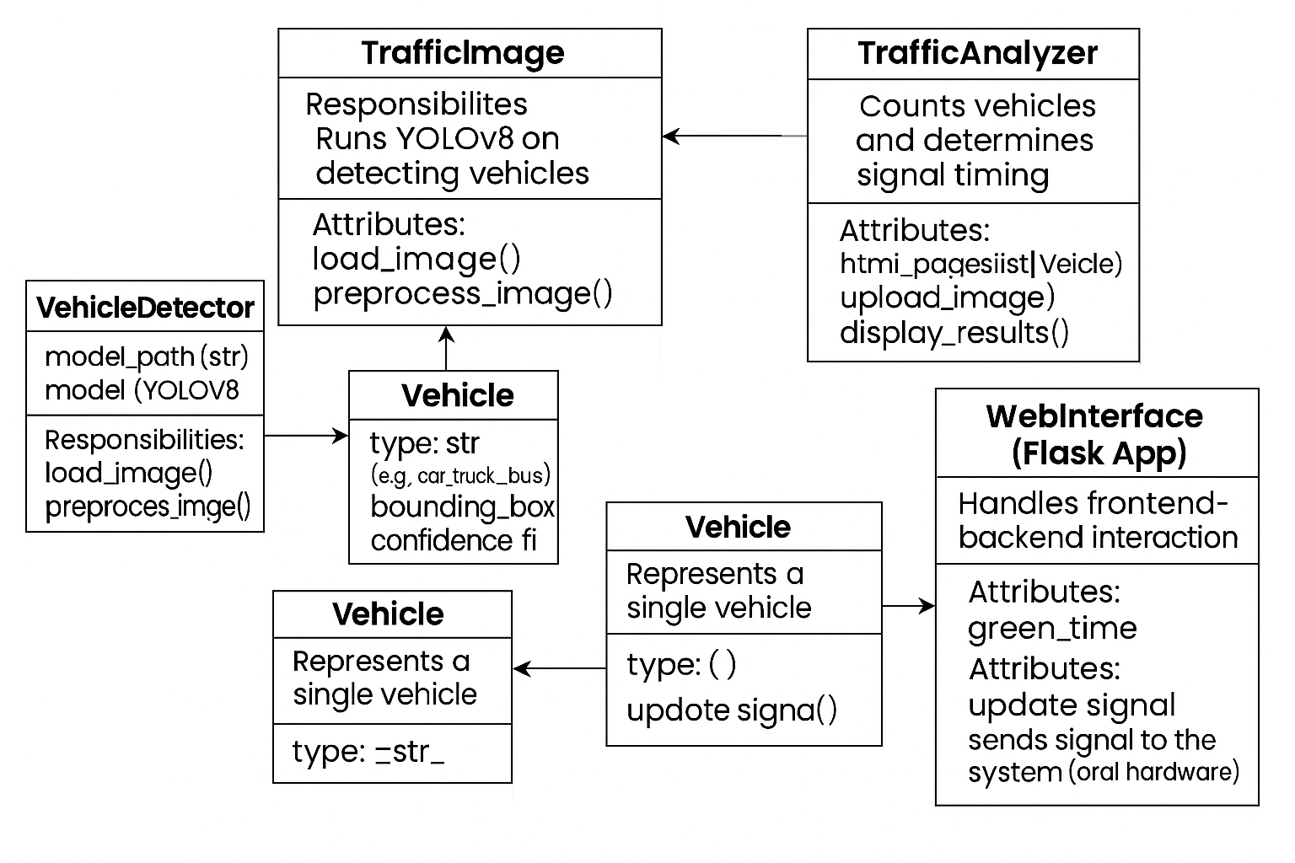

**5.1.1 Class Diagram**

* Captured frame is sent to the YOLOv8 object detection model.
* YOLOv8 detects vehicles and sends the vehicle count.
* Traffic Analyzer receives the count and calculates the optimal green signal time.
* Green time is sent to the Traffic Controller to update the signal status.
* Traffic Controller activates the green light and starts the timer.
* Timer is displayed for vehicles to view the remaining signal time.

**5.2 UML DIAGRAMS**

* **Use Case Diagram**

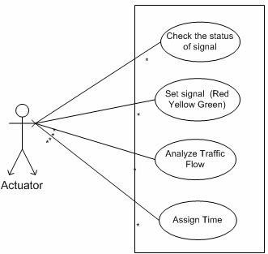

**5.2.1 Use Case Diagram**

* Check the status of signal: The actuator verifies the current status of the signal (Red, Yellow, or Green).
* Set signal (Red, Yellow, Green): Based on the analysis, the actuator sets the appropriate signal color.
* Analyse Traffic Flow: The actuator receives traffic data (likely from the camera or learner module) and interprets traffic density or vehicle count.
* Assign Time: The actuator assigns optimal green signal time based on the analysis result
* **Sequence Diagram**

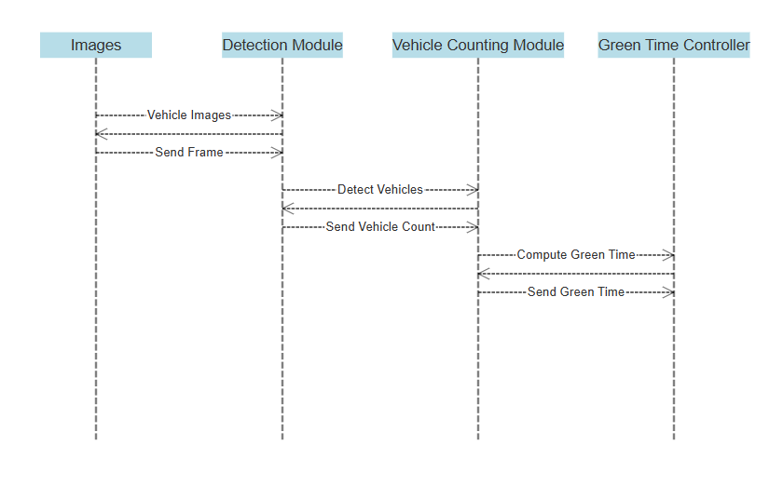

**5.2.2 Sequence Diagram**

* Images – The module/camera that captures live traffic images.
* Detection Module – Uses YOLOv8 to detect vehicles from the frames.
* Vehicle Counting Module – Counts the number of detected vehicles.
* Green Time Controller – Calculates optimal green signal duration.
* **Activity Diagram**

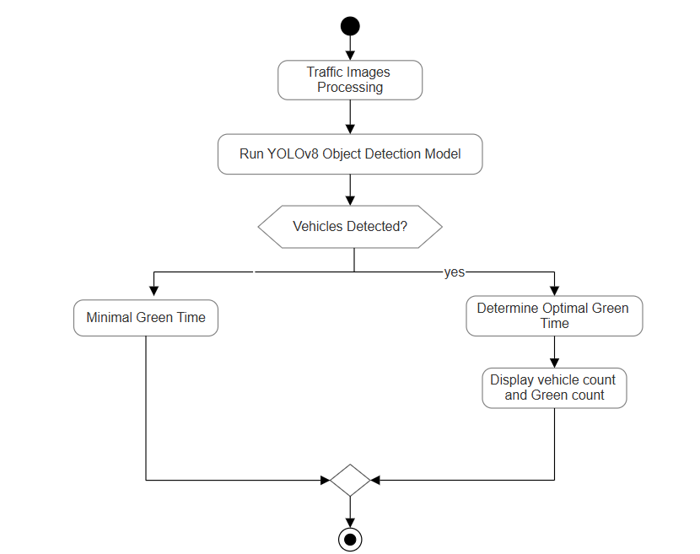

**5.2.3 Activity Diagram**

* The system begins by processing live traffic images captured from the camera.
* These images are passed through the YOLOv8 Object Detection Model to detect vehicles.
* A check is performed: Are vehicles detected?
* If no vehicles are detected, the system assigns a Minimal Green Time to that signal.
* If vehicles are detected, the system:
* Determines the Optimal Green Time based on vehicle count.
* Displays both vehicle count and corresponding green signal time.
* After execution, the signal continues to the next state in the traffic cycle.

**5.3 SYSTEM ARCHITECTURE**

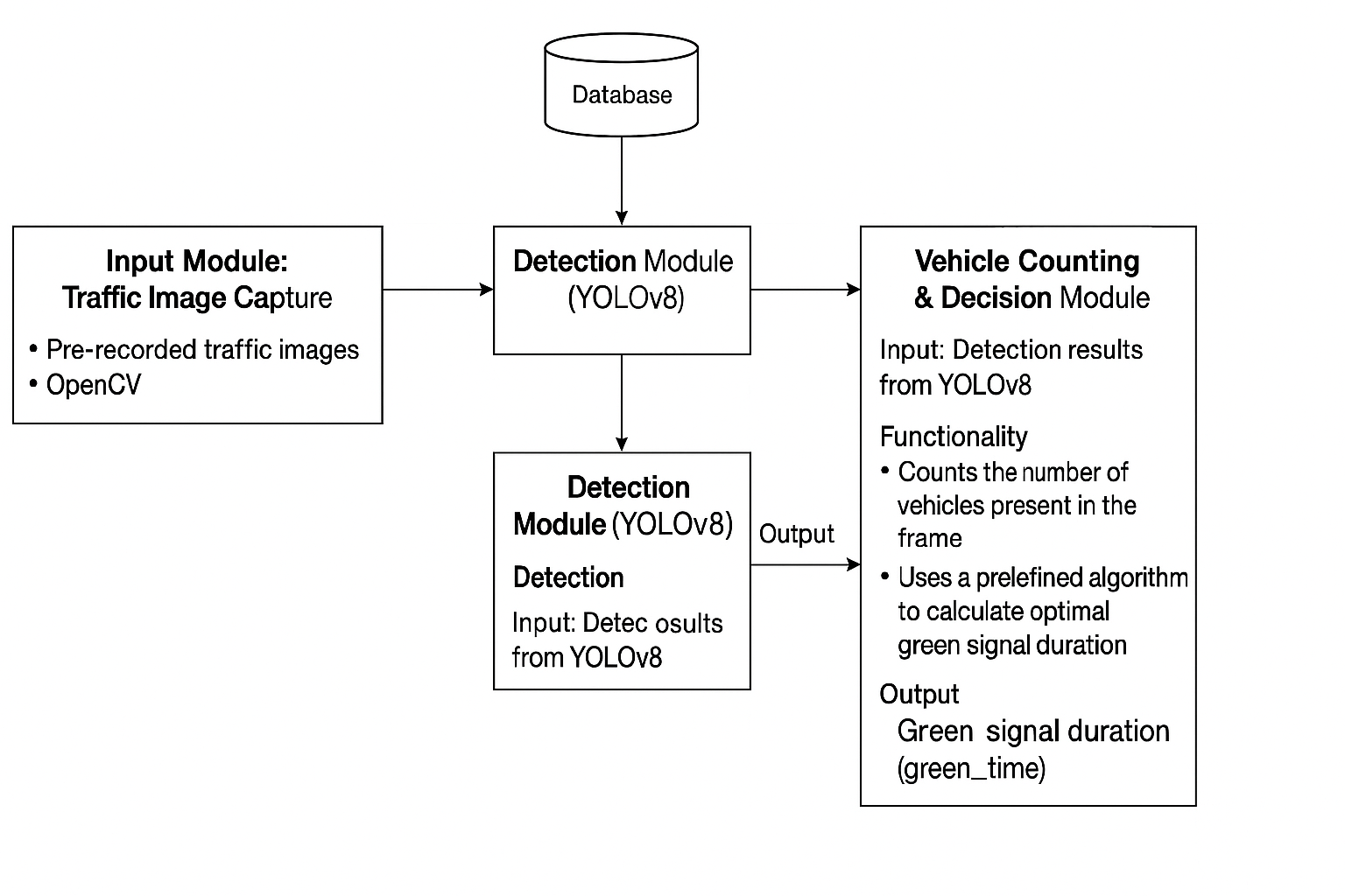

**5.3.1 System Architecture**

**1. Input Module:**

Captures traffic images using OpenCV or pre-recorded footage.

**2. Detection Module (YOLOv8):**

Uses YOLOv8 to detect vehicles in the captured frames.

**3. Database:**

Stores the detection data for further analysis or logging.

**4. Vehicle Counting & Decision Module:**

Takes detection results, counts vehicles, and calculates green signal duration using a predefined algorithm.

**5. Duplicate Detection Block:**

This seems redundant and can be merged with the main Detection Module.

CHAPTER - 6

**CODING AND IMPLEMENTATION**

**6. CODING AND IMPLEMENTATION**

**6.1 METHODOLOGY**

Developing a smart traffic control system involves a structured methodology that includes model development, system integration, and real-time deployment. The implementation follows key stages to ensure accuracy, efficiency, and scalability.

**Methodology for Coding**

A. Data Collection & Preprocessing

* Gather traffic surveillance images representing various traffic densities (low, medium, high).
* Annotate vehicle positions using labeling tools compatible with YOLO format.
* Preprocess images (resizing, augmentation, normalization) for optimal model training.

B. Model Development

* Use the YOLOv8 architecture (e.g., YOLOv8n) for object detection.
* Fine-tune the pre-trained model using the annotated dataset for better accuracy on traffic scenes.
* Optimize the model for CPU deployment due to AWS Free Tier constraints.
* Export the trained model weights (best.pt) for inference.

C. Backend Development

* Use Flask (Python) for building APIs and handling image uploads.
* Integrate the backend with the deployed SageMaker endpoint for real-time inference.
* Develop logic to calculate green signal timing based on the number of vehicles detected in each lane.

D. Frontend Development

* Design a simple web interface using HTML, CSS, and Bootstrap.
* Implement image upload functionality in index.html.
* Display signal timing results and vehicle count in results.html.

**Implementation Approach**

A. System Architecture & Integration

* Adopt a modular structure separating: Frontend (user interface), Backend logic (Flask), Inference engine (YOLOv8 model on SageMaker).
* Use AWS SageMaker for model hosting and EC2 for the Flask server.
* Use base64 encoding to transmit image data to the model endpoint.

B. Testing and Optimization

* Perform unit testing of imagedetect.py to ensure accurate vehicle detection.
* Conduct integration testing for image upload, API communication, and green signal calculation.
* Optimize inference time by resizing images and reducing payload size.
* Monitor model latency and endpoint stability via Amazon CloudWatch.

C. Deployment & User Feedback

* Deploy the frontend and Flask backend on an AWS EC2 instance.
* Deploy the YOLOv8 model on AWS SageMaker (CPU instance).
* Collect test feedback to evaluate prediction accuracy and system responsiveness.
* Iterate and refine green signal logic or model if needed for higher accuracy.

**6.2 SAMPLE CODE**

**imageDetect.py**

from ultralytics import YOLO

import cv2

model = YOLO(".venv/yolov8n.pt") # You can replace this with a fine-tuned model later

# Replace with your test image path

image_path = ".venv/traffic-jamz-2.jpg"

results = model(image_path)

# Class IDs for vehicles in COCO dataset

vehicle_classes = [2, 3, 5, 7] # car, motorcycle, bus, truck

vehicle_count = sum(

1 for cls in results[0].boxes.cls if int(cls.item()) in vehicle_classes

)

print(f"Detected {vehicle_count} vehicles.")

**app.py**

from flask import Flask, render_template, request

from ultralytics import YOLO

import os

import cv2

app = Flask(__name__)

model = YOLO(".venv/yolov8n.pt")

os.makedirs("uploads", exist_ok=True)

os.makedirs("static/processed", exist_ok=True)

vehicle_classes = [2, 3, 5, 7]

def count_vehicles_and_save(image_path, output_path):

results = model(image_path)

result = results[0]

# Count vehicles

vehicle_count = sum(1 for cls in result.boxes.cls if int(cls.item()) in vehicle_classes)

# Load image with OpenCV

img = cv2.imread(image_path)

# Draw clean boxes manually

for box in result.boxes:

cls_id = int(box.cls[0])

if cls_id in vehicle_classes:

label = model.names[cls_id]

x1, y1, x2, y2 = map(int, box.xyxy[0])

cv2.rectangle(img, (x1, y1), (x2, y2), (0, 255, 0), 1) # thin box

cv2.putText(img, label, (x1, y1 - 5),

cv2.FONT_HERSHEY_SIMPLEX, 0.4, (255, 255, 255), 1) # small text

# Save the cleaned image

cv2.imwrite(output_path, img)

return vehicle_count

def calculate_green_time(vehicle_count):

base_green_time = 15 # Base green time in seconds

vehicle_multiplier = 2 # Additional time per vehicle

# Constraint: If vehicle count is 10 or less, use only base time

if vehicle_count<=5:

time=10

return time

elif vehicle_count <= 10:

return base_green_time

else:

green_time = base_green_time + (vehicle_count * vehicle_multiplier)

return green_time

@app.route('/', methods=['GET', 'POST'])

def index():

if request.method == 'POST':

files = request.files.getlist('images')

results = []

for i, image in enumerate(files):

if image:

filename = f"frame{i + 1}.jpg"

upload_path = os.path.join("uploads", filename)

output_path = os.path.join("static/processed", filename)

image.save(upload_path)

count = count_vehicles_and_save(upload_path, output_path)

time = calculate_green_time(count)

results.append({

"frame": i + 1,

"image": filename,

"count": count,

"time": time

})

return render_template("result.html", results=results)

return render_template("index.html")

if __name__ == "__main__":

app.run(debug=True)

**index.html**

<!DOCTYPE html>

<html lang="en">

<head>

<meta charset="UTF-8">

<title>Smart Traffic</title>

<style>

body {

font-family: 'Segoe UI', Tahoma, Geneva, Verdana, sans-serif;

background: linear-gradient(to right, #74ebd5, #9face6);

margin: 0;

padding: 0;

display: flex;

justify-content: center;

align-items: center;

height: 100vh;

}

.container {

background-color: #ffffffcc;

padding: 40px;

border-radius: 15px;

box-shadow: 0 4px 12px rgba(0, 0, 0, 0.2);

text-align: center;

max-width: 400px;

width: 90%;

}

h2 {

color: #333;

margin-bottom: 20px;

}

input[type="file"] {

margin: 20px 0;

padding: 8px;

border: 2px dashed #aaa;

border-radius: 8px;

width: 100%;

background-color: #f9f9f9;

}

button {

padding: 10px 20px;

font-size: 16px;

border: none;

border-radius: 8px;

background-color: #4CAF50;

color: white;

cursor: pointer;

transition: background-color 0.3s ease;

}

button:hover {

background-color: #45a049;

}

</style>

</head>

<body>

<div class="container">

<h2>Upload Traffic Images</h2>

<form method="POST" enctype="multipart/form-data">

<input type="file" name="images" multiple required accept="image/*">

<br>

<button type="submit">Upload Images</button>

</form>

</div>

</body>

</html>

**result.html**

<!DOCTYPE html>

<html lang="en">

<head>

<meta charset="UTF-8">

<title>Traffic Analysis Results</title>

<link href="https://fonts.googleapis.com/css2?family=Inter:wght@400;600&display=swap"

rel="stylesheet">

<style>

body {

font-family: 'Inter', sans-serif;

background: linear-gradient(to right, #74ebd5, #9face6);

margin: 0;

padding: 20px;

}

h1 {

text-align: center;

color: #2c3e50;

}

.grid-container {

display: grid;

grid-template-columns: repeat(2, 1fr);

gap: 25px;

max-width: 1000px;

margin: 30px auto;

}

.frame-card {

background: #fff;

border-radius: 12px;

box-shadow: 0 4px 12px rgba(0, 0, 0, 0.08);

overflow: hidden;

transition: transform 0.2s ease;

}

.frame-card:hover {

transform: translateY(-5px);

}

.frame-img {

width: 100%;

display: block;

border-bottom: 1px solid #eee;

}

.frame-info {

padding: 15px;

}

.frame-info h2 {

margin: 0 0 10px;

color: #34495e;

font-size: 18px;

}

.frame-info p {

margin: 4px 0;

font-size: 15px;

color: #555;

}

.back-button {

display: block;

margin: 30px auto;

background: #3498db;

color: white;

padding: 12px 24px;

border: none;

border-radius: 6px;

font-size: 16px;

text-decoration: none;

text-align: center;

transition: background 0.3s;

}

.back-button:hover {

background: #2980b9;

}

</style>

</head>

<body>

<h1>Traffic Lane Analysis Results</h1>

<div class="grid-container">

{% for result in results %}

<div class="frame-card">

<img class="frame-img" src="{{ url_for('static', filename='processed/' ~ result.image) }}" alt="Frame {{ result.frame }}">

<div class="frame-info">

<h2>Frame {{ result.frame }}</h2>

<p><strong>Total Vehicles:</strong> {{ result.count }}</p>

<p><strong>Green Time:</strong> {{ result.time }} seconds</p>

</div>

</div>

{% endfor %}

</div>

<a class="back-button" href="{{ url_for('index') }}">← Upload More Images</a>

</body>

</html>

CHAPTER – 7

**SYSTEM TESTING**

**7. SYSTEM TESTING**

The purpose of testing is to discover errors. Testing is the process of trying to discover every conceivable fault or weakness in a work product. It provides a way to check the functionality of components, sub assemblies, assemblies and/or a finished product It is the process of exercising software with the intent of ensuring that the Software system meets its requirements and user expectations and does not fail in an unacceptable manner. There are various types of test. Each test type addresses a specific testing requirement.

**Types of System Testing**

* Unit Testing
* Integration Testing
* Functional Testing
* Performance Testing
* Security Testing
* Usability Testing
* Compatibility Testing

**7.1 SYSTEM TESTCASES**

|  |  |  |  |  |
| --- | --- | --- | --- | --- |
| **Test Case** | **Test Data** | **Expected Result** | **Actual Result** | **Status (Pass/Fail)** |
| Launch Web App | Click on the “Run” button in Flask app | Web application starts and homepage loads | Web application starts and homepage loads | Pass |
| Object Detection Execution | Uploaded traffic image | Vehicles detected and counted | Vehicles detected and counted | Pass |
| Multiple Images Handling | Upload 2+ traffic images | All images processed, results shown for each frame | All images processed, results shown for each frame | Pass |

**7.2 UNIT TESTING**

|  |  |  |  |  |  |  |
| --- | --- | --- | --- | --- | --- | --- |
| **Test Case ID** | **Module** | **Test Case** | **Test Data** | **Expected Result** | **Actual Result** | **Status** |
| UT-01 | Image Upload | Upload Image | Traffic image (JPEG/PNG) | Image successfully uploaded | Image successfully uploaded | Pass |
| UT-02 | Object Detection | Run YOLOv8 Detection | Uploaded traffic image | Vehicles correctly identified and classified | Vehicles correctly identified and classified | Pass |
| UT-03 | Count Vehicles | Count by Class | Detection result from YOLOv8 | Vehicle count returned | Vehicle count returned | Pass |
| UT-04 | Signal Time Logic | Calculate Green Time | Vehicle count | Appropriate green time calculated | Appropriate green time calculated | Pass |

**7.3 INTEGRATION TESTING**

|  |  |  |  |
| --- | --- | --- | --- |
| **Test Case ID** | **Description** | **Expected Result** | **Status** |
| 1 | Image Upload to Detection Pipeline | Uploaded image is successfully passed to YOLOv8 model for object detection | Pass |
| 2 | Detection Output to Traffic Signal Module | Detected vehicle count is used to calculate traffic light timing | Pass |
| 3 | Flask Backend to Frontend Display | Processed image with bounding boxes is returned and displayed on the webpage | Pass |
| 4 | Error Handling Integration | Invalid inputs (e.g., no image or wrong format) are handled gracefully across system | Pass |

CHAPTER - 8

**OUTPUT SCREENS**

**8. OUTPUT SCREENS**

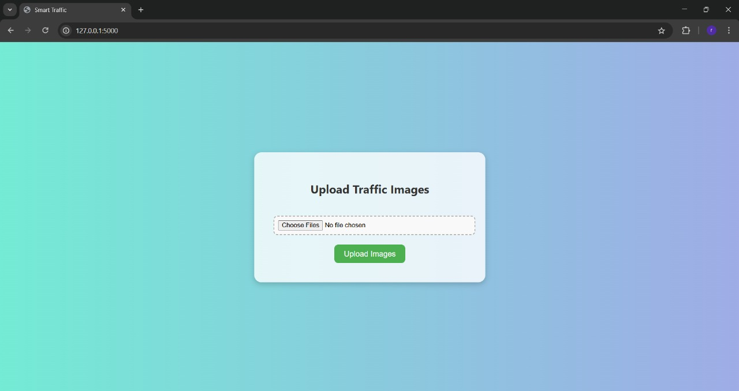

**Figure 8.a :** Main Page

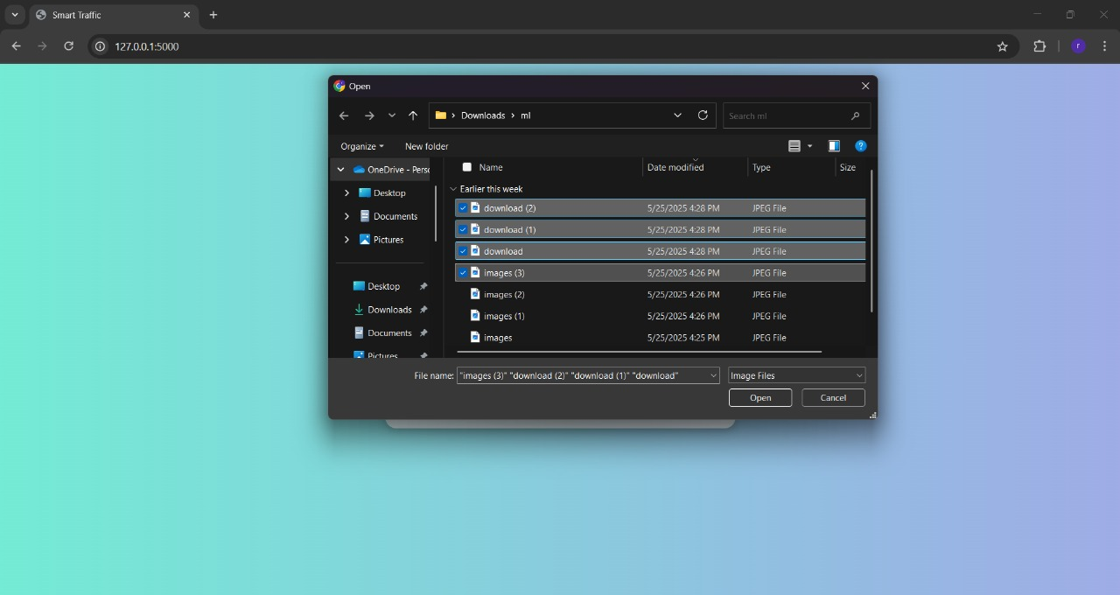

**Figure 8.b :** Selection of images

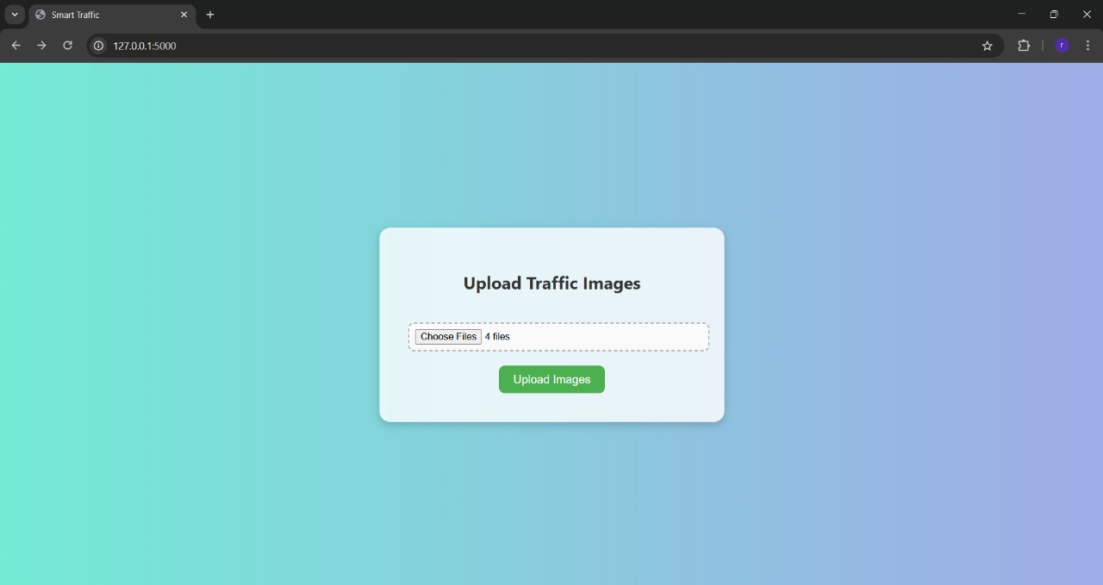

**Figure 8.c :** Main Page

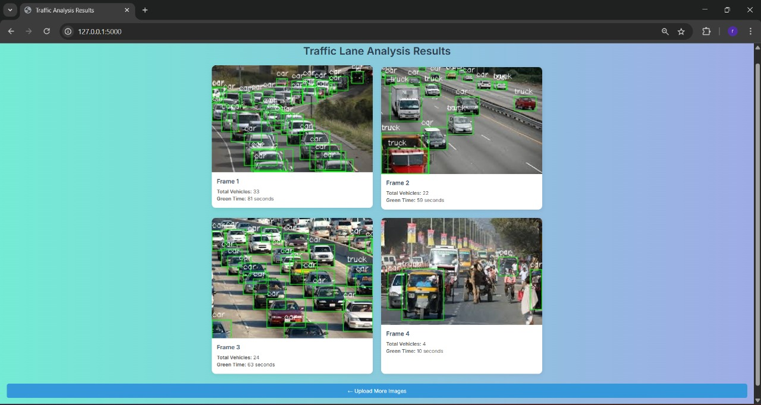

**Figure 8.d :** Result Page

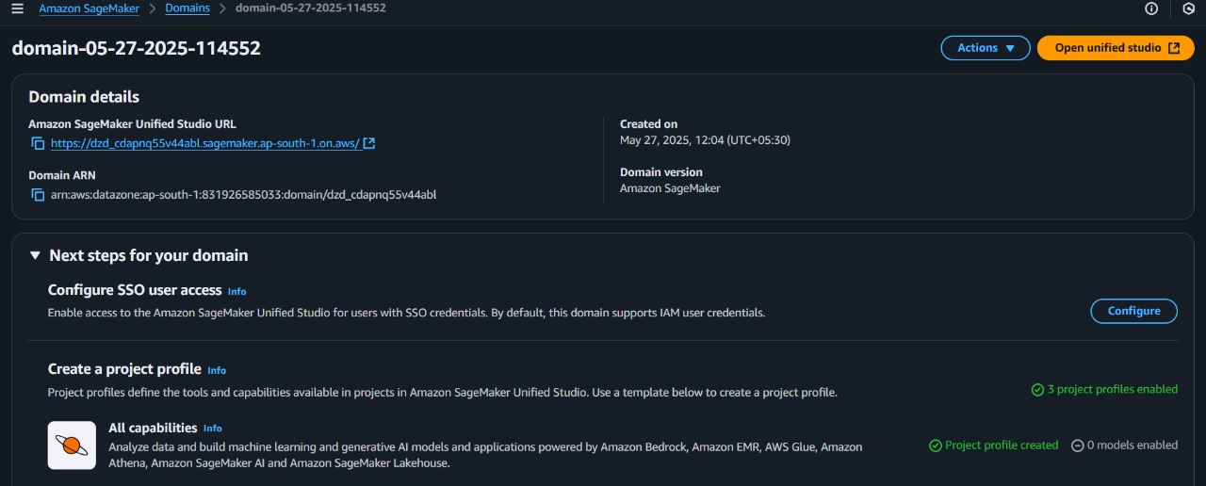

**Figure 8.e :**  SageMaker Domain Creation

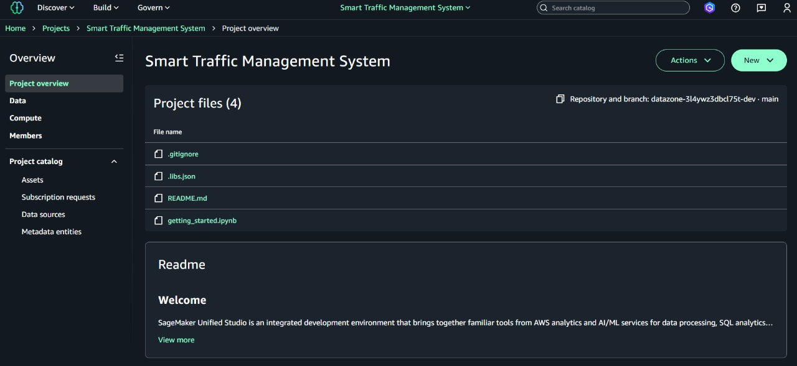

**Figure 8.f :**  Project Folder

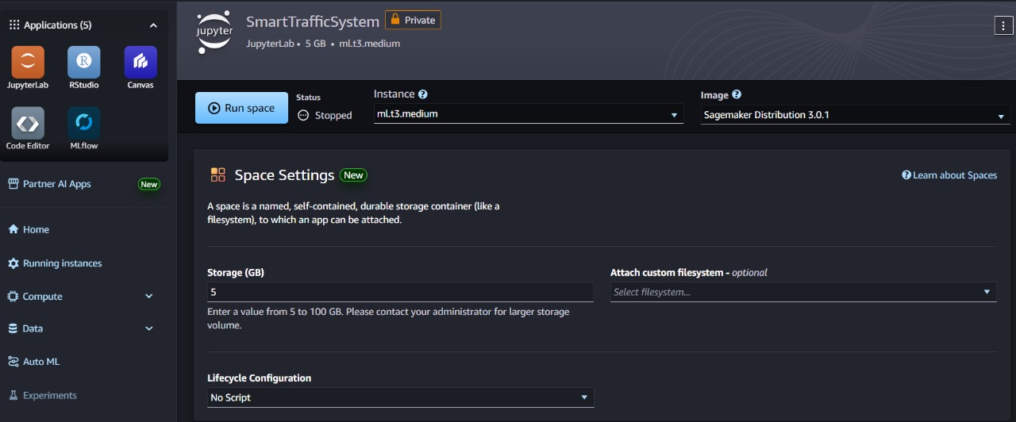

**Figure 8.g :**  SageMaker Studio

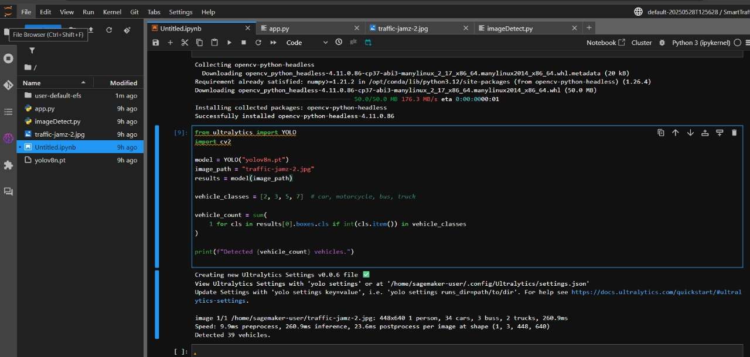

**Figure 8.h :**  Deployment of model



**Figure 8.i :**  Testing

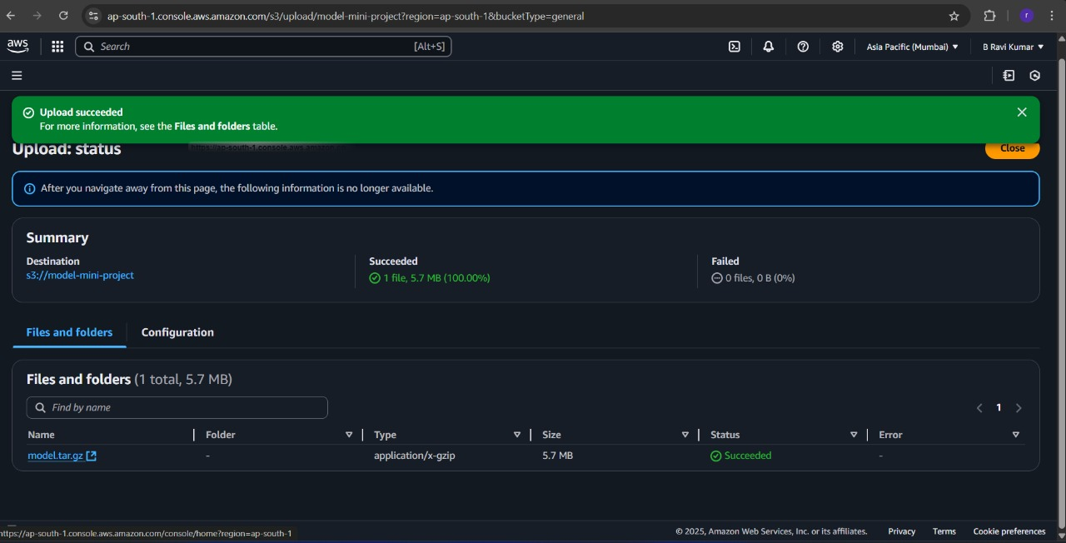

**Figure 8.j :**  Creation of S3 Bucket

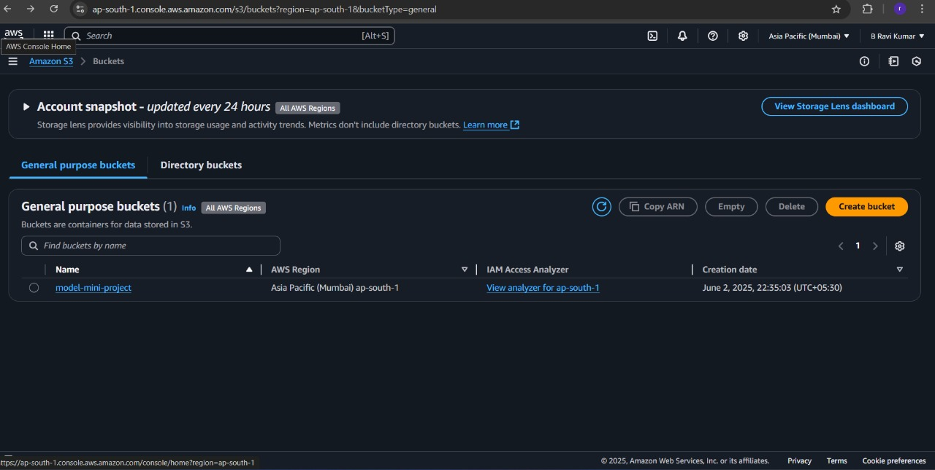

**Figure 8.k :**  Uploading of Model

CHAPTER - 9

**CONCLUSION**

**9. CONCLUSION**

The Smart Traffic System developed in this project provides a practical and efficient solution for real-time traffic management using computer vision and machine learning. The system leverages the YOLOv8 object detection model to identify and count various types of vehicles in traffic footage. By analyzing the density of vehicles, it can make informed decisions to optimize traffic signal timings dynamically, thus contributing to smoother traffic flow and reduced congestion.

Deployed using AWS SageMaker, the system benefits from cloud scalability, fast inference, and seamless integration with other AWS services. The choice of a cloud-based deployment model allows for processing large volumes of traffic data efficiently, ensuring the solution remains responsive even in high-traffic scenarios. Furthermore, using pre-trained models reduces training overhead while still achieving accurate and reliable performance.

Throughout development, the focus remained on building a robust and scalable architecture that could be integrated into modern smart city infrastructure. The modular nature of the code and API-based design also make it easy to maintain, extend, and deploy across multiple intersections and cities.

This project successfully showcases the potential of combining machine learning with real-world applications to address common urban problems. It not only improves the flow of traffic but also minimizes waiting time at signals, indirectly contributing to reduced fuel consumption and pollution.

Overall, the Smart Traffic System is a step toward intelligent urban mobility and reflects the growing importance of AI-powered automation in everyday life.This smart traffic system demonstrates a practical solution for reducing congestion and enhancing urban mobility. With accurate vehicle detection and adaptive signaling, it ensures efficient traffic flow. The model's flexibility allows for further improvements, making it a reliable foundation for building smarter, more responsive, and sustainable traffic management solutions. .

CHAPTER – 10

**FUTURE ENHANCEMENT**

**10. FUTURE ENHANCEMENT**

* **Ambulance Detection and Priority Handling:** The system can be enhanced to identify emergency vehicles like ambulances in real-time using deep learning-based object recognition. Once an ambulance is detected approaching an intersection, the system will override normal signal sequences and instantly turn the light green for the ambulance’s lane, ensuring it gets uninterrupted passage. This can significantly reduce response time during emergencies and save lives. Integration with GPS and hospital emergency dispatch systems could further improve efficiency.
* **Multi-Camera Integration:** To scale the solution beyond a single intersection, the system can be extended to support multiple camera feeds from various junctions across a city. A centralized dashboard can manage and analyze inputs from all cameras in real time, enabling a coordinated city-wide traffic management network. This would allow authorities to monitor and control traffic patterns on a macro level, reroute vehicles in congested areas, and optimize traffic flow holistically.
* **Weather and Lighting Adaptation:** Traffic systems must perform reliably in all conditions. To ensure accuracy during night time, fog, rain, or other low-visibility scenarios, the system can be upgraded to use infrared or thermal imaging cameras alongside standard video feeds. These additional sensors would help detect vehicles and obstacles even when visual data is impaired, maintaining system performance and safety under adverse environmental conditions.
* **Violation Detection System:** The smart traffic system can be improved by incorporating modules that detect traffic rule violations, such as red light jumping, overspeeding, and lane violations. The system can automatically capture vehicle images and license plate numbers, and send real-time alerts to traffic authorities. Additionally, accident detection capabilities can be included to identify collisions based on motion anomalies or object displacement, triggering immediate emergency response protocols.

**11. REFERENCES**

[1] J. Redmon, S. Divvala, R. Girshick, and A. Farhadi, “You Only Look Once: Unified, Real-Time Object Detection,” *Proc. IEEE Conf. Computer Vision and Pattern Recognition.* 2016. *https://doi.org/10.1109/CVPR.2016.91*

[2] A. Bochkovskiy, C.-Y. Wang, and H.-Y. M. Liao, “YOLOv4: Optimal Speed and Accuracy of Object Detection,” .2020. [*https://arxiv.org/abs/2004.10934*](https://arxiv.org/abs/2004.10934)

[3] Ultralytics, “YOLOv8 Documentation,” 2024. [Online]. *https://docs.ultralytics.com/yolov8/*

[4] M. Abadi et al., “TensorFlow: Large-Scale Machine Learning on Heterogeneous Distributed Systems,” 2016. [*https://arxiv.org/abs/1603.04467*](https://arxiv.org/abs/1603.04467)

[5] Himanshu Singh, “Practical Machine Learning with AWS: Process, Build, Deploy, and Productionize Your Models Using AWS”. 2021. [*https://www.amazon.com/Practical-Machine-Learning-AWS-Productionize/dp/1484262212*](https://www.amazon.com/Practical-Machine-Learning-AWS-Productionize/dp/1484262212)

[6] D. P. Kingma and J. Ba, “Adam: A Method for Stochastic Optimization,”. 2014. [*https://arxiv.org/abs/1412.6980*](https://arxiv.org/abs/1412.6980)

**11.1 TEXTBOOKS**

1. Deep Learning – *Ian Goodfellow, Yoshua Bengio, Aaron Courville*
2. Hands-On Machine Learning with Scikit-Learn, Keras, and TensorFlow – *Aurélien Géron*
3. Programming AWS Lambda – *Marko Sluga*
4. Flask Web Development – *Miguel Grinberg*
5. Advanced Machine Learning with Python – *John Hearty*

**11.2 WEBSITES**

1. *https://docs.ultralytics.com* – Official YOLOv8 Documentation (Ultralytics)
2. *https://flask.palletsprojects.com* – Flask Web Framework Documentation
3. [*https://docs.aws.amazon.com/sagemaker*](https://docs.aws.amazon.com/sagemaker) – Amazon SageMaker Documentation
4. [*https://opencv.org*](https://opencv.org) – Official OpenCV Library Website